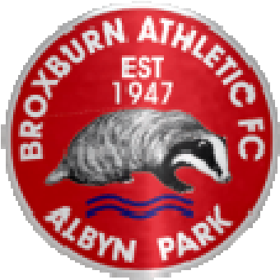

Disability Policy
Broxburn Athletic is committed to ensuring access to the football club for disabled and less able supporters and staff is as effective and efficient as we can make it and that all supporters are able to enjoy their time with us at the Albyn Park.
Broxburn Athletic will ensure that there is no discrimination between disabled people with differing impairments and will make every effort to comply fully with its legal obligations as set out in the Equalities Act 2010.
In early December 2019 the club embarked on creating a suitable area for disabled spectators to view matches at the Albyn Park in a secure, comfortable environment.
The area sits within the covered enclosure towards the west end of the park. Access to it can either be through the turnstiles, past the boxing club and along the flat tarmac before entering the enclosure by way of a ramp (1.2m wide/7.34m long with 1:12 gradient). Within the new disability area, spectators are under cover. There is accommodation for 3 wheelchair users + 3 seated assistants – (landing platform 2.09m/2.04m and seated area 3.86m/2.2m)
Access can also be made through the main gates at the clubhouse with a similar flat tarmac path to the enclosure.

Accessible Toilets
Toilet facilities for disabled spectators are all easily accessible and the schedule of toilet provision at each level is as follows:
Cafe/Bar Level 1 via lift from reception area | 1 disabled unisex WC
Ground Level – Pitchside (left of Pavilion entrance) | 1 disabled unisex WC

Refreshment Facilities
Café - Outside | Right of Club House entrance – pitchside.  Wheelchair accessible.
Café/Bar - Room for All | Access through ground level Club House entrance and elevator located in Reception

The committee are fully aware for the need to offer any assistance to wheelchair users and there are individuals available to ensure that any requests for help are acquiesced to in a friendly manner.

Parking
Disabled parking is available outside the main entrance and signs are fully displayed.

Emergency Evacuation
The evacuation plan will depend on the location of any incident and the location of wheelchair positions. Spectators are requested at all times to follow the directions and advice of the appointed stewards. Please note that stadium lift will not be available for the evacuation of wheelchair users during an emergency.
Any queries not covered by the above information should be directed to Gordon Lowden, Club Disability Officer.

20 December 2018

